**Abstract**

Anthocyanins are essential for the quality of perennial horticultural crops, such as grapes. In grape, ELONGATED HYPOCOTYL 5 (HY5) and MYBA1 are two critical transcription factors that regulate anthocyanin biosynthesis. Our previous work has shown that VvBBX44, a B-box (BBX) protein, inhibits anthocyanin synthesis and represses *VvHY5* expression in grape calli. However, the regulatory mechanism underlying this regulation was unclear. In this study, we found that loss of *VvBBX44* function resulted in increased anthocyanin accumulation in grapevine callus. VvBBX44 directly represses *VvMYBA1* which activates *VvBBX44*. VvMYBA1, but not VvBBX44, directly modulates the expression of grape UDP flavonoid 3-O-glucosyltransferase(*VvUFGT*). We demonstrated that VvBBX44 represses the transcriptional activation of *VvUFGT* and *VvBBX44* induced by VvMYBA1. However, VvBBX44 and VvMYBA1 did not physically interact in yeast. The application of exogenous anthocyanin stimulated *VvBBX44* expression in grapevine suspension cells and tobacco leaves. These findings suggest that VvBBX44 and VvMYBA1 form a transcriptional feedback loop to prevent overaccumulation of anthocyanin and reduce metabolic costs. Our work shed light on the complex regulatory network that controls anthocyanin biosynthesis in grapevine.

**Keywords:** anthocyanin, VvBBX44, VvMYBA1, feedback regulation, grape

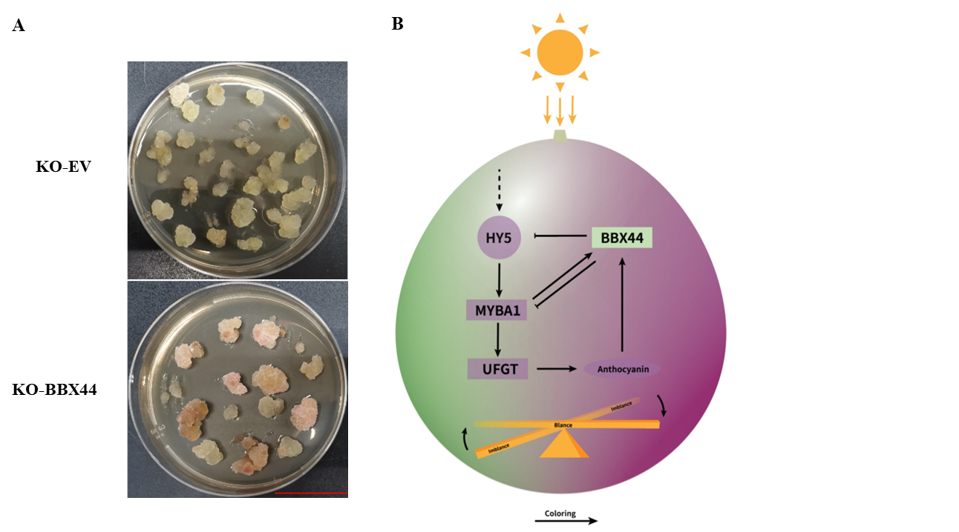

**A model for the BBX44-MYBA1 regulatory loop controlling anthocyanin biosynthesis in grapevine berry.** (A) Knockout of BBX44 increased anthocyanin accumulation in grapevine callus. Scale bar is 3 cm. (B) When berries are exposed to light, VvMYBA1 is activated by VvHY5, promoting the transcription of *VvUFGT*, and anthocyanin biosynthesis is stimulated. At the same time, VvMYBA1 activates the transcription of *VvBBX44*. When the anthocyanin concentration reaches a threshold level, it also induces the transcription of *VvBBX44*. In turn, VvBBX44 directly represses the transcription of *VvMYBA1* and *VvHY5* and *VvUFGT* expression is decreased, thus resulting in a balance of anthocyanin concentration.